**Implementing an Acuity Scale for Staffing in the Inpatient Setting:**

**An Evidenced Based Practice Project**

Kristen Brunelle, Carmin Erickson, and Sarah Fulton

NUR 696: Seminar & Service Project I

Claudia Dietrich

January 17th, 2021

**Acknowledgements**

Creating, researching, and implementing a strong evidence-based practice (EBP) project requires the immense support and reassurance from the necessary people. Without the devotion and support of the University of Mary this project would not have been possible. Through the solid foundation of the master's degree programs we were able to build a relevant and timely EBP project. In addition, we would like to express our sincere gratitude to our project advisor, Claudia Dietrich, for being a guiding force and expert resource to allow us to travel this new and exciting path to increasing nursing satisfaction and improving nursing retention.

Moreover, this project would not have been completed without the support of CHI St. Alexius Health Dickinson Medical Center in Dickinson, ND. CHI St. Alexius Health in Dickinson allowed us to bring our project to life by collaborating and opening their organization to our project. An incredibly special thank you is extended to their Vice President of Patient Care Services and Interim CEO DeeAnna Opstedahl, as she more than willingly volunteered to be an organizational and leadership mentor and help develop this project idea.

Finally, we would like to extend a sincere thank you to our family and friends who eased our project by being supportive and understanding of this journey. Without their continuous provision and encouragement this project would not have been successful and meaningful.

**Table of Contents**

Executive Summary 8

Problem Statement: Scope of Clinical Problem from a Global Perspective 10

Significance of Clinical Problem at the Organizational Level 12

PICOT Question 13

Purpose Statement 13

Review of Literature 14

Literature Search 14

Table 1 14

*External data* 14

Table 2 15

*Literature Matrix Grid* 15

Synthesis of Current Literature 19

*Current Precedence* 20

*The Case for Acuity Based Staffing* 21

*Drawbacks* 23

*Implementation & Recommendations* 24

Project Problem Identification 27

Internal Evidence 27

External Evidence 30

Project Recommendations 31

Recommendation One: Educate Nursing Staff 32

Recommendation Two: Implement Acuity Tool 32

Project Implementation Plan 32

Change Theory 33

Key stakeholders 35

Barriers and Facilitators/Drivers to Resistors to Change 36

Business Impact 37

Organization Planning Process 39

Implementation Action Plan 39

Project Measurement Plan 42

Human Subject Protection Statement 43

Implementation and Measurement 44

Implementation 44

Project Outcome Measurements 47

Hand-Off Plan 49

Conclusion 49

References 51

**List of Tables**

Table 1: External Data......................................................................................................12

Table 2: Matrix Grid.........................................................................................................12

Table 3: Internal Data/Quality Data..................................................................................26

**List of Figures**

Figure 1: Staffing Worksheet........................................................................................................25

Figure 2: The ADKAR Model.....................................................................................................30

Figure 3: Acuity-Based Staffing Survey.......................................................................................33

**List of Appendices**

Appendix A: CHI St. Alexius Mission and Vision Statement

Appendix B: Nursing Satisfaction Questionnaire

Appendix C: Press Ganey Performance Scorecard

Appendix D: Staff Pulse Survey

Appendix E: Proposed Acuity-Based Staffing Tool

Appendix F: Action Plan

Appendix G: Institutional Review Board (IRB) Application

Appendix H: Organizational Letter of Support

Appendix I: Letter to ICU Staff

# **Executive Summary**

Courage, conviction, strength, and superhero these are a few of the adjectives that have been used to describe nurses throughout the Covid-19 pandemic. These words while well intentioned, have carried a bit of sting to nurses working in the trenches throughout one of the scariest global health crises this generation has seen. This sting comes from a place of overwhelming politicization of this health crisis, overwhelming patient loads, unsafe working conditions, and burnout, all old problems rearing their fangs in fine fashion; you have a profession that is at its knees. However, despite these incredible challenges there is a pulsation occurring within the nursing profession and it feels like the absolute inevitability of change.

The University of Mary team is utilizing the latest evidence to implement an acuity-based staffing matrix with the help CHI St. Alexius Health in Dickinson, ND and their executive leadership team. Similar to other health care organizations around the world CHI St. Alexius found that nursing staff was spread thin at the height of the Covid-19 pandemic with heavy workloads, high patient volumes, and short staffing. This led to a significant increase in staff turnover, a decreased in nurse satisfaction, and subsequent decrease in patient satisfaction. These findings prompted leadership to look at changing the way patient assignments were made as a way of ensuring equity among nursing assignments thus ensuring that one nurse isn’t carrying more weight of the unit than another team member. In collaborating with leadership, the University of Mary Team began the process of finding a staffing matric that would fit the organization’s needs. The PICO question that guided this project is as followed: *In the inpatient nursing unit (P) how effective is staffing based on an acuity scale for nursing patient assignments (I) compared to staffing based on productivity (C) on improving nursing satisfaction and decreasing staff turnover by the end of July 2021?*

A deep-dive into the literature produces compelling evidence for the implementation of acuity based staffing including O’Keefe (2016) who found a significant increase in productivity for units that implements acuity based staffing. Kidd et al., (2014) also saw nursing satisfaction increase from 7 percent to 55 percent following implementation of acuity-based staffing on a medical-surgical unit. Further, numerous professional organizations including The American Nurses Association, The Centers for Medicare and Medicaid, The Joint Commission, and The Institutes of Medicine all agree that acuity-based staffing as a safe, effective, and evidence-based staffing method. With this insight the University of Mary Team has set out to create a staffing matrix that not only aligns with the literature but also fits the needs of CHI St. Alexius Health in Dickinson, North Dakota.

**Implementing an Acuity Scale for Staffing in the Inpatient Setting:**

**An Evidenced Base Practice Project**

The University of Mary Project Team joined with CHI St. Alexius in Dickinson, ND, to execute an Evidenced-Based Practice (EBP) project to implement an acuity scale for staffing in the inpatient setting. For decades nursing assignments have been created based on productivity with little acuity being accounted for. Workloads that are uneven have a significant association between nursing satisfaction and turnover. Nursing satisfaction is not directly correlated to the ease of their workload, but their ability to tend to their patient changing changes. Patient assignments that do not support the nurse's ability to promote excellent patient outcomes may cause them to feel inadequate and frustrated (Carvalho et al., 2019).

The University of Mary Project team will work in collaboration with CHI St. Alexius Health to apply an acuity tool to assist in appropriate staffing based on patient needs and acuity. The goal of this project is to assign patients appropriately based on their acuity, decrease nursing turnover and increase nursing satisfaction. When nurses feel they are caring for patients to the top of their scope it is proven they have higher satisfaction and patients have better outcomes. The EBP project will be developed, implemented, and measured by the University of Mary Project Team and CHI St. Alexius Health to evaluate nursing staff satisfaction and turnover rates. It has been proven that organizations that recognize the nursing burnout and dissatisfaction can provide corrective measures and improve their nurse satisfaction and retention by creating working conditions conducive for nurses to perform properly.

## **Problem Statement: Scope of Clinical Problem from a Global Perspective**

Globally and nationally, the COVID-19 pandemic has placed immense stress on health care organization and their workers. The full impact is just beginning to present itself in the aftermath of 2020. Feelings of personal vulnerability, the worry of possibly infecting loved ones, social distancing, isolation, and rapidly changing work conditions raised stress levels to an all new high. Additionally, if quarantined, employee’s fear of susceptibility, helplessness, and trauma levels rose significantly resulting in job-related burnout. In fact, thirty-five percent of health care workers report moderate-to-severe trauma-related distress, fifteen percent moderate-to-severe depression, twelve percent anxiety, and eight percent insomnia as a result of the ongoing pandemic (Ruiz & Gibson, 2020). Identifying pandemic effective ways to mitigate adverse outcomes related to the pandemic will aid in improving working environments for health care workers. Minimizing personal stress to assist others is common in care providers so providing a manageable level of work best serves nurses, patients, and the organization (Ruiz & Gibson, 2020).

Interestingly, staffing models have generally not changed in the last fifty years. Depending on acuity levels, nurse to patient ratios should be based at minimum to reflect patient status whether stable or unstable, skilled intervention level, and organ system level support needs (Hill, 2020). The United Kingdom Critical Care Nursing Alliance reported the emergency nursing workforce model initiated during the pandemic cannot be sustained.

Prior to the pandemic, the nursing workforce was already under significant stress related to absenteeism, high turnover, career inequality, working conditions, and “chronic excessive work pressures” (Glasper, 2020, p. 1292). Fostering health and wellbeing in an environment where nurses may fully exhibit their skills and clinical expertise is priority when considering supportive efforts through provision of managerial support and promotion of collaborative teamwork. Alignments between the two are vital when offering support to nurses to ensure optimal patient outcomes (Glasper, 2020).

## **Significance of Clinical Problem at the Organizational Level**

CHI St. Alexius Health in Dickinson has identified several gaps in their current staffing model. Currently, patient assignments are made based on a productivity model that fails to distribute patient loads equitably among staff nurses. For the last few decades, customary practice for patient assignments evaluates patient volume, job requirements, nursing duties, and the nurses credentialing i.e., LPN or RN, not patient acuity. During the COVID-19 pandemic, the need for adjustment to the current staffing tool became apparent. COVID-19 patients require a higher level of nursing care due to strict PPE and isolation requirements. Additionally, these patients often have difficulties with many Activities of Daily Living (ADL’s) and exhibit an elevated level of anxiety which often results in tedious nursing care. Due to this demanding workload nurses have become frustrated, they feel unsupported for their efforts, and are exhibiting signs of burnout.

Consequently, the University of Mary Project Team in partnership with CHI-St. Alexius Dickinson identified a need to create and implement an EBP project that would provide nursing leaders with a tool to evaluate patient acuity and thus assign nursing staff accordingly. The tool will provide a visual guide to ease delegation of work assignments thus ensuring patient assignments are tailored to the nurse’s education level and experience, while also positively impacting patient safety and outcomes. The goals of this EBP project are to increase nursing satisfaction, reduce turnover, and mitigate burnout syndrome. Furthermore, creating a standard assignment worksheet will improve work relationships between nursing leadership and nursing staff. CHI St. Alexius Health Dickinson is a 25 bed, critical access facility employing 150 nurses in Southwest North Dakota. The focus of this project is the Medical Surgical (Med/Surg) Unit comprised of 30 nurses.

## **PICOT Question**

The initial step in an EBP project is to ask a question in a PICOT formatted question to help determine the population (P), intervention (I), comparison (C), outcome (O), and time (T). The purpose of a PICOT question is to identify terms to be used to explore the best evidence to assist in answering the purposed clinical question. Gallagher & Melnyk (2019) describes the PICOT question as part of the search strategy that brings unbiased and effective evidence to provide evidenced-based recommendations, decisions, or practice. A good PICOT question can produce a robust EBP project and strong recommendations that lead to improved patient outcomes.

For this EBP project, the PICOT question is: *In the inpatient nursing unit (P) how effective is staffing based on an acuity scale for nursing patient assignments (I) compared to staffing based on productivity (C) on improving nursing satisfaction and decreasing staff turnover by the end of July 2021?*

P = Inpatient nurses on the Medical and Surgical Unit.

I = Implementation of staffing based on an acuity scale for nursing patient. assignments.

C = Compared to staffing based on productivity.

O = Increasing nursing satisfaction and decrease staff turnover.

T= By end of July 2021

## **Purpose Statement**

The purpose of this project is to implement an acuity-based staffing model that promotes nursing satisfaction and decreases nursing turnover. The intent of this project is to explore an acuity-based staffing model and its effect on nursing satisfaction with their patient assignments. It is hypothesized that an acuity-based staffing model will ensure more equitable patient assignments thus improving nurse's overall satisfaction with patient assignments. Currently CHI St. Alexius Health utilizes a staffing model that is based on a productivity formula. It was recognized during the COVID-19 pandemic that the current formulas failed to distribute patient workloads equitably due to the significant increase in acuity of the patient population. The project will be implemented in the Med/Surg unit at CHI St. Alexius Health Dickinson Medical Center in Dickinson, ND.

# **Review of Literature**

## **Literature Search**

The present review of literature was conducted utilizing the Boolean phrases outlined in Table 1 the databases that were queried included CINAHL, Medline, and Health Source. Table 1 outlines the Boolean phrase utilizes on each database and the number of hits that were generated from each phrase. Queries were filtered down to only include full text references, articles published no later than 2010, and articles published in English. After articles were filtered down the articles were quickly evaluated for quality and substance by evaluating the synopsis of articles. Following, the rapid evaluation 25 articles were selected for more in-depth analysis, following in-depth evaluation ten articles were selected to support the present project.

# **Table 1**

# *External data*

|  |  |  |  |
| --- | --- | --- | --- |
| Key Search Terms | *CINAHL* | *MEDLINE* | *Health Source* |
| 1. Patient Acuity | 9,474 | 13,684 | 910 |
| 1. Nurse Staffing | 5,983 | 2,309 | 1,796 |
| 1. Nurse Workload | 2,145 | 1,103 | 524 |
| 1. Nurse Satisfaction | 7,947 | 3,829 | 1,888 |
| 1. Nursing Turnover | 1,168 | 569 | 276 |
| 1. 1 and 2 | 226 | 113 | 4,198 |
| 1. 1 and 3 | 92 | 45 | 2,187 |
| 1. 1 and 4 | 67 | 36 | 17,477 |
| 1. 1 and 5 | 24 | 5 | 1,702 |
| 10. 2 and 3 | 257 | 133 | 67 |
| 11. 3 and 4 | 165 | 93 | 44 |
| 12. 1, 2, and 4 | 8 | 7 | 91 |

# **Table 2**

# *Literature Matrix Grid*

|  |  |  |  |  |  |  |  |  |
| --- | --- | --- | --- | --- | --- | --- | --- | --- |
| Full APA reference Citation | Research Purpose | Study Design | Sample (Setting) | Data Collection/ Measures | Analysis/ Outcomes | Strengths/ Limitations | Joanna Briggs Level of Evidence | Study Quality |
| American Nurses Association. (2019). *ANA's Principles for Nurse Staffing.* Silver Spring: American Nurses Association. | The present article outlines guidance for organizations to tailor an appropriate nurse-to-patient staffing matrix | Expert Opinion | N/A | N/A | ANA provides several metrics for health care organizations to follow when it comes to implementing a more equitable nursing staffing matrix. | This report serves as guidance, it is not a research study and there is no empirical evidence that the guidance provided will result in effective staffing models. | Level 4 | Strong level expert opinion from a reputable source |
| Hertel, R. (2012). Regulating Patient Staffing: A Complex Issue. *Med-Surg Matters, 21*(1), 3-7. | The present article evaluates legal precedence and regulations for nurse staffing around the country. It also outlines the case for regulating as well as the case against regulations. | Expert Opinion | N/A | N/A | The article evaluated nurse staffing regulations passed in California and followed legislation being evaluated in 14 other states. The article also went on the evaluate the merits for regulating nurse staging and also evaluated the shortcomings of regulation. | The report is simply informative and is not a primary research study. | Level 4 | Medium |
| Ingram, A., & Powell, J. (2018). Patient acuity tool on a medical-surgical unit. *American Nurse*, 1-7. | The present research article looked at the effectiveness of an acuity tool in making patient assignments for nurses more equitable. The study measured nurse satisfaction and nursing perception of patient safety. | Evidence-Based practice project | 23 bed medical-surgical unit in Durham, VA | Pre-test post-test data collection. Nursing satisfaction and nurse’s perception of safety was evaluated pre pilot implementations and post-pilot implementation. | Researchers found a significant increase in nurses satisfaction with their patient assignments, and their perceptions of patient safety. | This serves as a pilot study, and may suffer from inability to generalize to other units or areas | N/A not research | Low-level Evidence |
| Kidd, M., Grove, K., Kaiser, M., Swooda, B., & Taylor, A. (2014). A new patient- acuity tool promotes equitable nurse- patient assignments. *American Nurse Today, 9*(3), 1-4. | The present article sought to evaluate an acuity tool that would better disperse acuity among all staff nurses. | Evidence-Based practice project | Progressive care unit at University Health Ball Memorial Hospital in Muncie | Nurses satisfaction was assessed by an eight-item survey. This survey was administered 1 month before project implementation and then 1 month, 6 months, and 12 months following study implementation. | Nursing satisfaction increased from 7 percent to 55 percent following study implementation | There is no comparison group and the tool used to evaluate nursing satisfaction is not provided thus its validity cannot be determined | N/A | Low-level evidence |
| Malloch, K. (2012). Changing Tides: Increasing Evidence to Embrace a Patient Classification System. *Nursing Economics, 30*(6), 356-358. | The present article serves to identify the necessity of acuity-based staffing and outlines not only the benefits to nurses and patients but also the benefits to the organization as a whole. | Case Report | N/A | N/A | This report indicates that acuity-based staffing holds the potential to significantly increase quality of care while also making healthcare more equitable. | This is a case report thus it is subject to bias. | Level 4 | Moderate- quality |
| Malloch, K., & Meisel, M. (2013). Patient Classification Systems State of the Science 2013. *Nurse Leader*, 35-40. Doi: 10.1016/j.mnl,  2013.09.008 | The present report outlines the merits of acuity-based staffing, the different patient classification systems and the current available literature on acuity-based staffing or patient classification systems. | Descriptive case report | N/A | N/A | This report outlines the history of acuity-based staffing, some of the merits, challenges, and future goals of patent classification systems | This is a descriptive case report and does not provide empirical data to fully back up its claims | Level 3 | Moderate- quality |
| O'Keeffe, M. (2016). Practical steps for applying acuity-based staffing. *American Nurse Today, 11*(9), 30-34. | The present article looks at acuity-based staffing and presents the research in support of acuity-based staffing. It also goes on to outline the business case for acuity- based staffing. | Descriptive case-report | N/A | N/A | This report makes the business case for acuity-based staffing and outlines its benefits based on the current body of literature. | It does not present any opposing views to acuity- based staffing meaning it could be subject to bias. | Level 4 | Moderate- quality |
| Trepanier, S., Lee, D. W., & Kerfoot, K. M. (2017). Interoperable Acuity-Based Staffing Solutions: Lessons Learned From a Multi-Hospital System. *Nursing Economics, 35*(4), 184-204. | This study evaluated the effectiveness of an acuity tool on making more equitable patient assignments in a large health care organization. | Pre-test Post-test design | Premier Health in Dayton, OH | Study looked at decreasing variability among staffing assignments and increasing equity of care for patients | Study found nurses were more satisfied with their patient work loads. | It does not outline there goals or anticipated outcomes, nor does it outline any evaluation tools for collecting this data and ensuring the goals of the project are achieved | Level 2 | Moderate- level |
| Vortherm, J., Spoden, B., & Wlcken, J. (2015). From Evidence to Practice: Developing an Outpatient Acuity-Based Staffing Model. *Clinical Journal of Oncology, 19*(3), 332-337. | The present study sought to evaluate the use of an acuity tool in an outpatient oncology infusion center in order to more appropriately assign patient work loads. | Pilot study Experimental non- randomized control trial | 35- chair outpatient oncology infusion center | Study evaluated the use of an acuity tool in allocating patients to nurses based on a total level of acuity for the shift, this was compared to a group in which patients were assigned per standard method for the unit which was done through subjective decision making by the charge nurse for the day. | Implementation of the acuity tool found that staffing was more consistent, things ran more efficiently, overtime was reduced, and both patients and staff were more satisfied | It is a pilot study and therefore is difficult to generalize to other areas. Additionally there was no randomiza- tion between the two groups. | Level 2 | High-quality |
| Wallace, B. C. (2013). Nurse staffing and patient safety: What's your perspective. *Nurse Management*, 49-51. | This case report outlines the dangers of boiling staffing down to a simple numbers game and makes the case for staffing that is vested in nursing knowledge, patient needs, while also emphasizing the importance of having the appropriate tools available to perform the job correctly. | Case Report | N/A | N/A | Report denotes that using numbers to justify staffing can be dangerous because it leads to the false sense of security that more staff equals better outcomes. However, staffing needs to be more tailored based on patient condition, nursing skills sets/ knowledge and available resources | This is a case study so it may be subject to bias | Level 4 | Medium- quality |

### **Synthesis of Current Literature**

The act of prioritizing patients based on acuity dates back to the grandmother of nursing Florence Nightingale herself. Nightingale was known to prioritize patients based on their nursing needs and coded patients from lowest to highest acuity depending on their condition. Based on this acuity system Nightingale knew the patients that would require more involved care thus allowing her to adjust her care appropriately. This sort of triage has become a tenant of the nursing profession, with nursing education being steeped in the teaching of nurses on patient prioritization, and yet the way nursing resources are allocated within many healthcare organizations fails to recognize this important tenant of the nursing profession. When a nurse is given a patient assignment in which all patients are perceived as high acuity it is extremely difficult for a nurse to prioritize her resources appropriately which may lead to sub-standard care. It is equivalent to, telling a firefighter to put a house fire out, but when the firefighters show-up they find that the whole block is on fire, how would one even begin to prioritize? According to the American Nurses Association (ANA) developing an appropriate nurse staffing matrix is a critical component for the delivery of safe, quality health care in every practice setting (American Nurses Association, 2019).

Other professional organizations are also beginning to understand the importance of more equitable nurse to patient staffing ratios including the Joint Commission, the Institutes of Medicine, The Centers for Medicare and Medicaid, and numerous other professional nursing organizations. The aforementioned institutions have made a call to action for organizations to reevaluate nurse staffing. While nurse-to-patient ratios have long been a point of contention, the Covid-19 pandemic has outlined just how critical the need for more appropriate staffing guidelines is. Due to this startling realization the absolute necessity of appropriate nursing staff ratios is starting to be recognized. A thorough review of the literature was performed by the University of Mary Project Team to understand the tenants of nurse staffing, professional organizations recommendations, and implementations strategies as a means of guiding and informing the current project.

### ***Current Precedence***

Acuity based staffing is not a new concept in nursing practice, nurses are skilled at the art of triage and prioritization and yet few organizations have embraced the concepts of staffing based on patient’s acuity and nursing skill mix. The current precedence for nurse staffing is commonly measured in terms of nursing hours per patient day. This method is often referred to as a grid model or staffing matrix. The grid model calculates the nursing hours per patient day by multiplying the number of patients based on the average unit census. This concept averages out nursing care between an anticipated patient load based on the clinical setting.(Trepanier, Lee, & Kerfoot, 2017). This method of allocating nurses time does very little to describe the nuances of a nurse’s care delivery, boiling down a nurse's skills to an average per patient makes little sense considering different disease, nursing care, and procedures may require more or less of the nurse's expertise.

The earliest versions of the staffing matrix or grid model dates to the 1930s, these models were based on industrial and manufacturing models. Manufacturing models used a time-and-motion method to determine required time for patient care tasks. This method evaluated the average amount of time needed to complete specific nursing tasks, timed nursing tasks were identified for a shift and thus the number of nursing staff was determined based on the total amount of time required to accomplish all the quantified tasks (Malloch & Meisel, 2013). It is evident that this method has significant shortcomings, it is extremely difficult to boil a nurse's day to average timed tasks; patient care requires much more nuance and tailored care, and nursing judgment and knowledge varies between nurses, these differences should be accounted for when it comes to implementing an appropriate staffing matrix.

Fortunately, organizations are beginning to recognize the shortcomings of current staffing matrixes, Sigma Theta Tau presented an Excellence and Evidence in Staffing Roundtable that provided resources and insight into what excellence in staffing may look like indicating that an appropriate staffing matrix is built on a dynamic and evidence driven process that seeks to conserve resources, optimize outcomes for patients, families, the workforce, and the organization (Malloch, 2012). Further legislation is starting to pop up all over the country regarding mandatory staffing ratios in hospitals as a way to combat understaffing. Californie implemented a state mandated nurse patient staffing level in 2003, and there have been 14 additional states that have passed or considered addressing mandatory staffing ratios (Hertel, 2012, O’Keeffe, 2016).

### ***The Case for Acuity Based Staffing***

While the status quo for nursing staffing models has been vested in the traditional staffing matric grid model there are some organizations beginning to recognize the value in acuity-based staffing. The goal of acuity-based staffing to more appropriately identify the number of hours required for a patient load based on the acuity of the patient load this allows caregivers to practice nursing effectively and safely (Malloch, 2012). Malloch (2012) further states that when organizations rely solely on ratio or grid staffing models, they fail to recognize the complexities of care delivery, critical thinking, and patient needs that can all vary among shift and between nurses. Grid or ration models simply quantify the minimum staffing requirements for an average unit census, whereas acuity-based staffing is based on empirical data that accounts for the range of patient care needs (Malloch, 2012). Acuity based staffing also makes more sense in the current healthcare environment in which payment structures demand high-quality care while also allowing organizations to retain savings gained through maximizing cost efficiency and meeting quality standards (O’Keeffe. 2016). Unbalanced patient assignments or shifts that fall just 8 hours short of target staffing levels shows a substantial increase in patient mortality (O’Keeffe, 2016). Additional evidence shows that understaffing is also associated with increased incidences of shock, bloodstream infections, and hospital-associated infections (Hertel, 2012).

There are numerous positive outcomes that acuity-based staffing produces particularly when it comes to nurse sensitive indicators. These indicators include falls, catheter associated urinary tract infections, central line associated bloodstream infections, and pressure-ulcer prevalence, studies showed a statistically significant decrease in all four indicators when staffing was adjusted to account for higher-acuity patients. Nurses in the study attributed the change to decreased overtime and having more time to complete their work during their shift (O’Keeffe, 2016). Further making the case for acuity-based staffing are other hospital quality metrics that have demonstrated significant improvement following its implementation include decreased mortality, fewer adverse outcomes, shorter overall length-of-stay, fewer incidents of cardiac arrests, and fewer failure-to-rescue events (Hertel, 2012). These findings can be attributed to acuity-based staffing’s ability to maximize patient and nursing outcomes through better decision making, improved operational outcomes, and improved nurse and patient satisfaction (O’Keeffe, 2016). The research makes a strong case for acuity-based staffing based on patient outcomes alone, however there is also a case to be made for acuity-based staffing when tackling other issues in healthcare like nursing satisfaction and organizational excellence.

The Joint Commission for Accreditations of Hospitals as early as 1980 made it a requirement that nursing units must ensure compatibility between nursing qualifications and their patient assignments making them one of the earlier advocators for acuity-based staffing (Malloch & Miesel, 2013). Further, codifying the case for acuity-based staffing is that Magnet accreditation is requiring healthcare organizations to base patient assignments and allocation of staff on patient care needs (Malloch & Miesel, 2013).

### ***Drawbacks***

While a large body of evidence concluded that acuity-based staffing is a positive force in health care, it is important to mention that not all come to this same conclusion. Hertel (2012) found that improving nurse-patient ratios did not positively impact quality of care, safety, or significantly impact overall length of stay. Additionally, articles out of California did not see any statistically significant changes in safety or quality outcomes regarding patient falls, and pressure injuries following the 2003 passage of mandatory nurse-patient ratios. There is also concern that strict regulation of patient ratios may significantly increase financial burden on organizations as well as result in unintended consequences like organizations implementing mandatory overtime in order to meet the required nurse-patient ratios. Further, to mitigate financial burden organizations may choose to reduce ancillary staff positions increasing overall patient burden on nurses.

Another study out of California found that organizations had decreased the use of unlicensed assistive personnel by 34 percent and non-nursing support services like housekeeping by 27 percent following stringent staffing regulation (Hertel, 2012). One of the last contraindications to acuity-based staffing lies in its complexity, it is difficult to measure the tasks performed by a nurse throughout their day, especially when evaluating the natural ebb and flow of a unit as this may result in a nurse providing care for numerous patients in a day which is not necessarily reflected in the hours per day or the nurse-patient staffing ratio (Vortherm, Spoden, & Wicken, 2015). This clashing of the data indicates that further high-quality studies need to be done to reach a level of saturations that can definitively state which staffing matrix creates the best quality care and promotes the highest nursing satisfaction.

### ***Implementation & Recommendations***

The American Nurses Association (ANA) (2019) does not endorse a one size fits all staffing matrix, however they do outline strong guidance on how to identify patient needs, nursing needs, and unit workflows in order to find the appropriate staffing model for a unit or care area. The ANA outlines the following core components when it comes to identifying the appropriate nurse staffing mix, nurses must be full partners with other healthcare professionals when it comes to ensuring high- quality care, organizations must have well-defined staffing guidelines, registered nurses should play a vital role in staffing decision making, staffing needs must be determined following an analysis of patient behaviors, the healthcare environment, nursing experience, tenure, and skill set, staffing must be cost effective, and reimbursement structures should not influence staffing patterns or the level of care provided (American Nurses Association, 2019).

Wallace (2013) draws many of the same conclusions the ANA does regarding implementation of an appropriate staffing model but denotes that while staffing is an integral piece of the puzzle, ensuring nurses have the appropriate supplies and support is equally as integral, stating that even the best staffing matrix is useless if staff don’t have the right supplies and support to get the job done. One study that set out to identify an appropriate staffing system determined that a common thread throughout the literature was the importance of nurse empowerment just as ANA stated, nursing voices are important and essential to the development of a new staffing tool (Kidd, Grove, Kaiser, Swooda, & Taylor, 2014). Kidd et. al. (2014), set out to create an appropriate acuity tool that would share the patient load among nurses more equitably as they were finding a significant increase in turnover, absenteeism, and overall disengagement among nursing staff in which it was identified that patient load was a major catalyst for these findings. After evaluating several tools data was brought back to the nursing staff and a tool was selected for implementation to help align patient load with both patient acuity and nursing expertise. After a month of the new tool implementation researchers found nursing satisfaction with the equity of their patient loads increase from 7 percent to a whopping 55 percent. Further, the study found a significant increase in overall consistence in patient loads increased from 21 percent to 89 percent. The tool was subsequently implemented as a permanent part of the nursing units (Kidd, Grove, Kaiser, Swooda, & Taylor, 2014).

A second study on the use of an acuity tool was undertaken by Ingram & Powell (2018) on a Medical Surgical unit. This study utilized an acuity scale that scored patients on a 1-to-4 scale with 1 indicating a stable patient, 2 moderate-risk patient, 3 complex patients and 4 high-risk patients. Nurses were tasked with scoring their patients based on predetermined criteria and provide this rating to the charge nurse who would than create patient assignments based on the acuity scores. Overall, the nurses on the unit found the tool easy to use, noninvasive to their workflow, and found it easily adaptable to different units. Another unexpected perk of the tool was its utilization in hand-off report as the tool served as a source of validation. Overall, the tool addressed the issue of unbalanced assignments and helped nurses influence decision-making in their organization. These findings codified that an acuity tool on a medical-surgical floor could create more equitable patient assignments, improve nurse satisfaction, and improve nursing perceptions of patient safety (Ingram & Powell, 2018).

The last study evaluated for this literature synthesis was done by Vortherm, Spoden, & Wicken (2015), this study took place in an outpatient infusion center where it was identified that nurses were increasingly dissatisfied with their workloads. To begin the study researchers gathered a multidisciplinary team that included nurses, physicians, schedulers, patients, and the cancer center executive director. Through strong collaboration it was decided that acuity would be spread more evenly between nurses using a tool that assigned acuity points based on the patient’s condition, treatment, and nursing needs. The charge nurse would identify the acuity of each patient on the schedule the day prior, and then disperse the acuity evenly among the nursing staff by adding the up the total acuity points for the day and dividing them by the number of nurses scheduled the following day. Patients are assigned based on their acuity scores assuring no nurse had more acuity than the average that was determined for the day. Additionally, if the average acuity for the day is greater than 60 it would indicate that more staff should be assigned for the day. Overall, the tool was able to provide significant improvement in the equitability of nursing resources. Researchers indicated the key to implementation and success was clear communication both written and verbal as well as welcoming and encouraging feedback from the multidisciplinary staff (Vortherm, Spoden, & Wicken, 2015).

From the research it is evident that there are numerous acuity tools that can be applied to different units and clinical situations, however the persistent message in the literature is the integral role nurses must play in developing an acuity tool that can be tailored to the job they do. Wallace (2013) states there is a major flaw in simply boiling down staffing to numbers promoting a belief that simply increasing staffing numbers without prior considerations to the level of clinical judgment and critical thinking skills each nurse possesses is dangerous and does little to improve quality care or nursing satisfaction. There is no one size fits all approach that will work for every unit; however, nurses have a professional obligation to report unsafe or inappropriate staffing. ANA suggests when implementing a new staffing matrix, mandatory overtime should never be a band aid for inappropriate or ineffective staffing models. Furthermore, nursing students and precepted students should never be treated as staff nor should students be a considered staff when determining staffing levels on any unit or care area (American Nurses Association, 2019)

# **Project Problem Identification**

## **Internal Evidence**

Internal evidence is based upon one’s own clinical expertise generated by quality outcomes, improvement projects, assessments, and evaluation of resources. EBP involves focus on both internal and external factors that contribute to decision making when considering practice changes (Melnyk & Fineout-Overholt, 2019). The goal of this project is to review, design, and implement a staffing model that addresses patient acuity in an inpatient setting using the internal evidence gained through observation and discussion of current delegation practices when assigning patients on the Med/Surg unit at a 25-bed critical access hospital.

Current practice involves a worksheet that has been in use for decades (Figure 1), a staff roster for reference, and charge nurse experience. Core staffing consists of a mix of four nurses (LPN & RN) on day shift with one CNA for an eight-hour shift. Night shift core staffing is a mix of four nurses (LPN & RN) with no CNA shift. The core staffing is centered upon a census of ten patients. Staffing is adjusted based upon productivity numbers and patient volume, not patient acuity. Shifts have a mix of nurse skill levels that may not be evenly distributed by degree or experience. The charge nurses assign according to patient condition, medication & treatment needs, and nurse experience.

**Figure 1**

*Currently Utilized Staffing Worksheet* 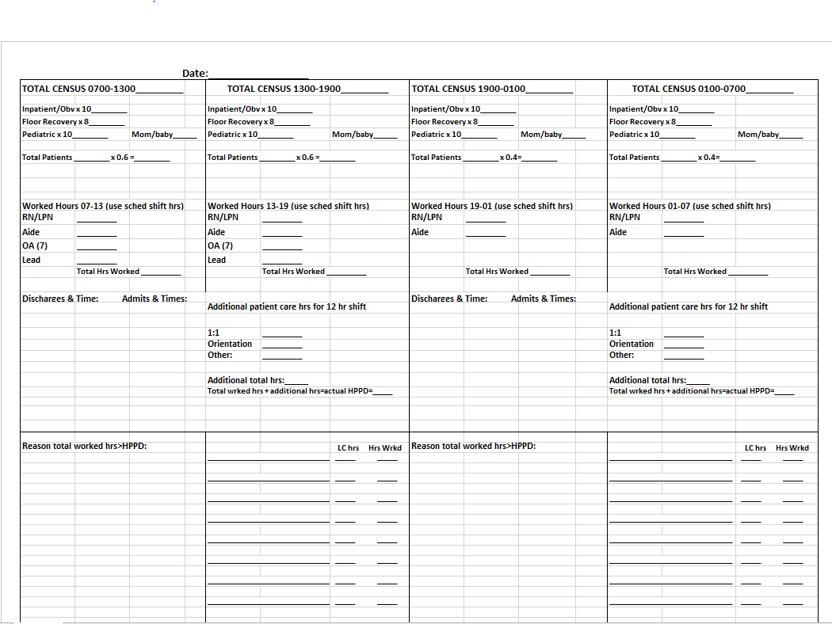

Until the COVID-19 pandemic of 2020, the current staffing model worked well for the unit most of the time. However, during the first COVID-19 community surge the staffing model shortcomings readily became apparent. Prior to the pandemic, because staffing is based upon volume and productivity many nursing position vacancies were not filled. When the surge hit, a limited number of nurses became stretched thin with heavy, high acuity patient assignments, extra shifts, and the added stress of uncertainty and fear. After time, exhaustion was tangible resulting in an increase in burnout and turnover.

To retain and recruit nurses, the Interim President of CHI St. Alexius Health Dickinson, ND DeeAnna Opstedahl, offered to support the University of Mary Project Team in an effort to engage in an EBP to improve the staffing assignment model by designing a tool that considers patient acuity in relationship to nursing experience and education rather than productivity. Using baseline staffing numbers and trends, engagement, and patient outcome scores, the University of Mary Project Team will create an effective assignment tool for implementation to optimize patient outcomes, error prevention, and staff satisfaction. Table 3 describes data collected for analysis, special considerations for each topic, and the source from which the data is obtained.

**Table 3**

*Internal Data*

|  |  |  |
| --- | --- | --- |
| Data Need | Special considerations | Source |
| Nursing satisfaction and engagement scores | Obtaining information from Human Resources (2020 is available, waiting for 2019). | Human Resources |
| Turnover percentages from 2019 versus 2020 | May not be fully indicative of staff satisfaction but relocation due to the local economy. | Human Resources |
| Number of nurses (LPN & RN) in the staffing pool for the Med/Surg Unit | Patient census varies rapidly and unexpectedly. | Human Resources |
| Average acuity of patients in 2020 versus 2019? | Availability of a report from the EMR that captures acuity levels. | Med/Surg Director or Clinical Informatics |
|  | | |

## **External Evidence**

As evidence by CHI St. Alexius’s Health Press Ganey scores there has been a significant decline in nursing satisfaction quality indicators. The external data from Kidd et. al. (2014), denotes that implementation of an acuity-based staffing matrix can lead to statistically significant increases in nursing satisfaction which correlated with improved nursing sensitive indicators like falls, pressure injuries, and adverse outcomes. Further, the recent internal data from CHI St. Alexius Health has demonstrated an increase in nursing turnover, and frontline staff are reporting symptoms of burnout to leadership. O’Keefe (2016) along with the American Nurses Association (2019), promotes acuity-based staffing as a way of empowering nurses, and improving nurse satisfaction with their workload, while also increasing productivity and decreasing overtime.

In working with staff there has been a small amount of ambivalence reported from front line staff in implementing the present project. This ambivalence stems from the medical-surgical unit having tried a form of acuity-based staffing in the past. This resistance is what makes empowerment integral to the implementation process, this is supported by Ingram & Powell (2018) who insist that nursing empowerment, continuous feedback, and a strong team dynamic are absolutely integral to the success of implementing a new staffing matrix. Nurses must feel that they are making the change they hope to see and not simply having change happen to them. Lastly, while empowerment and continuous feedback are integral elements to this project, as Wallace (2013) states ensuring nurses have the appropriate equipment to perform their work is just as important as finding the appropriate staffing matrix; because even the most effective staffing matrix is moot, if a unit lacks the appropriate equipment and supplies to ensure nurses work can be carried out appropriately and effectively. Thus, throughout this project the University of Mary team will garner continuous feedback to ensure not only that the staffing matrix is working but also ensuring that nurses have the appropriate tools and equipment to perform their jobs at the top of their scope.

Positive patient outcomes and satisfaction levels decrease when nursing job satisfaction scores are low (McHugh, et al., 2011). The University of Mary Project Team in collaboration with the organization mentor determined which metrics best highlight current gaps in nursing assignment processes in relation to nursing satisfaction. The following internal data sources decidedly provide the most accurate information; HCAHPS scores, Employee Pulse Surveys, quality metrics, length of stay, and staffing trends. The information gathered from these sources provides a vast pool of useful, accessible material for the purpose of this project. Additionally, data obtained from an inpatient nurse staff survey will serve as a baseline of the current nursing culture on the inpatient units. The survey will be repeated at the end of the project to aid in measuring nursing satisfaction levels in comparison with quality-of-care indicators.

# **Project Recommendations**

As nursing turnover increases and satisfaction decreases during the current pandemic a change must occur. It has been recognized that workforce models put in effect for COVID-19 are not sustainable and pre-pandemic national recommendations for ratios should be set (Hill, 2020). Hence, the recommendation of establishing staffing based on acuity and staff qualifications. Even prior to the pandemic the American Nurses Association (ANA) released The Principles for Nurse Staffing, which guides processes and polices to improve nurse staffing. The ANA believes strongly that appropriate nursing resources need to credit for a nurse's knowledge, experience, education, and skills set, in addition their patient mix, intensity, and acuity (Weston, Brewer, & Peterson, 2012). Utilizing these resources has demonstrated positive effects on nurse satisfaction and decreased nursing burnout.

Utilizing both the internal and external data analysis the University of Mary Project Team recommendations include implementation of an acuity-based staffing system to manage nursing inpatient staffing. This staffing system will assist in improved operational outcomes, increase nurse satisfaction, and assist in financial performance (O’Keeffe, 2016). Implementation of this staffing plan will produce increased nursing satisfaction and decrease staff turnover within six months’ time. After a comprehensive literature review, with the analysis of both internal and external data, two project recommendations were created.

## **Recommendation One: Educate Nursing Staff**

The University of Mary Project Team member and liaison Carmin Erickson along with CHI unit educators will educate nursing staff at the May inpatient unit meeting on the leadership selected color coded acuity-based staffing tool. CHI St. Alexius Health Leadership was presented with two different acuity-based staffing tools. Leadership requested to utilize the tool located in Appendix E, but also requested the document to be color-coded for easier readability. The tool then was adapted and approved to present to nursing staff.

## **Recommendation Two: Implement Acuity Tool**

The acuity-based staffing tool will be utilized by charge nurses to create patient assignments by June 1st. This will allow for one to two months of utilization prior to re-evaluation and dismissal of the University of Mary Project Team due to graduation.

# **Project Implementation Plan**

The purpose of this project is to design and implement a staffing plan based on the acuity scale for nursing patient assignments in the Med/Surg unit of CHI St. Alexius Health Dickinson Medical Center in Dickinson, ND. The organization currently utilizes a staff plan based on productivity formulas. This new staffing plan would assist in utilizing an acuity scale to improve nursing satisfaction with their patient assignments and overall decrease nursing turnover. Leadership at CHI St. Alexius Health was presented with two acuity scales that were identified as strong tools within the literature, after deliberation organizational leadership choose the scale from Kidd, M., Grove, K., Kaiser, M., Swooda, B., & Taylor, A. (2014). However, leadership liked the concept of including a color coding system as leadership felt this would be a fast way for charge nurses to quickly assess each floor nurses acuity workload. Thus, this team adapted the selected acuity tool per leaderships request (Appendix E).

## **Change Theory**

Change is the inevitable component of healthcare and leading this change can be a challenge for nursing leaders. Change theory can provide nurse leaders with the structure to support effective change and create sustainable environments. Jeff Hiat describes the ADKAR Model for change theory as a successful model because of its natural order to which people experience change. ADKAR stands for awareness, desire, knowledge, ability, and reinforcement (Hiatt, 2006). The ADKAR Model provides a strong change structure introducing an element of concrete strategies for goal attainment. For this EBP project, the University of Mary Project Team selected the ADKAR model because this model’s focus on the natural order of processing change creates a natural progression assisting in implementation.

**Figure 2**

*The ADKAR Model*

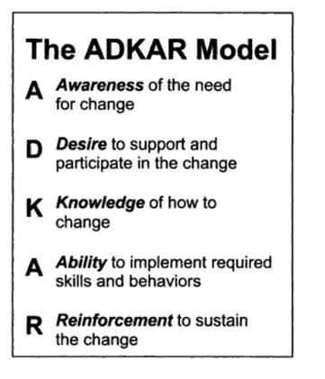

*Note*: From *“*ADKAR: A model for change in business, government, and our community” by J. Hiatt, 2006, *Hiatt*. Copyright by Hiatt

First, utilizing the ADKAR Model the team began to define and understand the “why” this change is necessary against the risk of not making a change. Once awareness is created then desire or willingness to change can be initiated. Stemming from personal choice, the desire to change can be influenced by utilizing intrinsic motivators that are unique to the individuals involved (Hiatt, 2006). The University of Mary Project Team recognized staff turnover has become an issue in the recent year and have proposed a solution to the organization and its staff to address the need for change in hopes that recognition will create a desire to participate in change.

The goal is to provide the knowledge including information, training, and education to move forward with the change, including and addressing behaviors, processes, tools, systems, skills, roles, and techniques that are needed to implement this change (Hiatt, 2006). Knowledge not only includes training and education but the staff’s ability to understand their part in the change and how they can participate responsibly both individually and within the group. Becoming reality once the University of Mary Project Team provides the tool, the staff will demonstrate capability in change implementation as described. Overall, ADKAR must be supported and reinforced by leadership to sustain change using internal and external factors. Leadership’s ability to reinforce internal reinforcements such as recognizing achievement or benefits may help to promote and sustain change.

## **Key stakeholders**

Key stakeholders are the individuals that have an invested interest in the process change and implementation that is produced by the EBP. It is crucial to include these individuals into the project initiation, management, and implementation. Key stakeholders for this project were identified by the University of Mary Project Team and the Vice President of Patient Care Services and Interim President of CHI St. Alexius Health – Dickinson. The key stakeholders include: The Vice President of Patient Care Services and Interim President DeeAnna Opstedahl, Med/Surg nurse managers, charge nurses, inpatient nurses, nursing educators, and the human resource team.

The focus of this project includes strong and supportive leadership to increase nurse satisfaction and decrease turnover. For CHI St. Alexius-Dickinson, the Vice President is in the top administrative position that leads these individuals, both in leadership and management in the Dickinson facility. As both Vice President of Patient Care Services and Interim President, this role accounts for immediate and future goals of the health care system including the target staff for this project.

The Lead Nurse of the Med/Surg inpatient unit is on a different level than the Charge Nurses of the front-line staff. Lead nurses report to the Director who reports to the Vice President of Patient Care Services. They are the leaders who work daily to coordinate the daily operations of their assigned units. They are responsible for managing and operating within the capital budget, maintain adequate staffing, utilize appropriate protocols and policies, and ensure staff is delivering safe and effective care. This position at CHI St. Alexius Health is responsible for leadership over all inpatient populations and specialties. More importantly, it is critical to include this group as they play a large part in nursing satisfaction and decreasing staff turnover. Charge nurses like Lead RNs create nursing assignments daily and are essential when utilizing the acuity scale and in ensuring staffing assignments are appropriate. Implementing an acuity scale includes education in not only implementation, but also to determine the nurses' credentials to ensure they are placed correctly when using acuity scales. Finally, nursing educators are identified as key stakeholders when considering project longevity and orientation of new staff nurses.

## **Barriers and Facilitators/Drivers to Resistors to Change**

Creating change does not come without its own set of barriers and drivers, these components can include staff, patients, leadership, human resources, and many other factors. Creating change takes time and active participation from all stake holders. It is in the leader's best interest to recognize both barriers and drivers when initiating change, when these two factors can be recognized then they than can be addressed and avoided or capitalized on. Effective implementation requires extensive effort from the leadership team, including inviting change champions to the table.

Nursing education includes utilizing evidence from EBP, yet several barriers still exist when implementing EBP into their practice. According to Labrague et al. (2019) literature reports that most barriers come from lack of support, opportunities, time, resources, and the authority to change practice. Nurses understand that EBP and research finding are important, but their understanding of EBP and their findings remain a large barrier. When leadership recognize these barriers and help guide nurse faculty the measures become more attainable and sustainable. This barrier could easily be turned into a driver by promoting the benefits behind it. In implementing the patient-based acuity staffing the nurse leaders need to first introduce this change and utilize the EBP surrounding it to support it. If nurse buy-in can be achieved to understand the goal is to increase their satisfaction and decrease their staff turnover, it may create more support around it. The ability to utilize the findings and evidence starts with the collaboration between the nursing faculty and their managers, this is key to successful translate evidence into clinical practice (Labrague et al., 2019).

Leaders can be a barrier or a driver in change. Adaptive leaders push boundaries of their current systems to strive for optimal services to both their staff and patients. This requires leaders to possess self-reflection, relationship building, strategic positioning, and inspire providers to share a creative vision (Hinton et al., 2019). Starting any process change begins with leadership relationships with their staff and colleagues, if this foundation is firm and respected then change is easier to grow on. If, however, this relationship is broken it creates an untrustworthy foundation in which change will be much more difficult to implement. CHI leadership is weary of change but have expressed they are open to any tool that will take the guess work out of creating assignments. They are especially interested in the possibility if it makes the work easier and provides an appearance of fairness for all stakeholders.

## **Business Impact**

Nurse turnover is both costly to patients and the organizations and is a crucial topic with administrators of healthcare organizations (HCO) today. High nurse turnover can cause a cascade of detrimental effects to an organization including, nurse dissatisfaction, safety, poor patient outcomes, patient loyalty, organizational productivity, and overall returns on investment. If an HCO can create an organization where nurses are highly satisfied and have low turnover, they will have competitive advantage.

In a global pandemic and even prior hospitals were struggling to retain their experienced nurses. The growing nursing turnover is cutting into organizations budget in a detrimental way. The 2019 National Healthcare Retention & RN Staffing Report stated that it costs an estimated $40,300 and $64,000 to replace a clinical nurse, this costs a hospital an average of $4.4 to $6.9 million dollars every year (NSI Nursing Solutions, 2019). The financial impacts of nursing turnover can cascade a hospitals financial situation into serious repercussions. The goal of this project is to turn the nurse turnover upside and work on retention to decrease financial costs to replace valuable nurses.

Accountable care organizations in the United States were implemented to address quality and assist in overall healthcare costs. These organizations met the quality measures and performed better than their fee-for service counterparts and produce modest cast savings (Wilson et al., 2020). Accountable care organizations work to improve the patient experience, enhance population health outcomes and reduce the cost of healthcare (Wilson et al., 2020). These organizations that help to ensure patients have an overall positive experience can ensure they are creating savings in expenses as well. Financially burdensome is not the only downfall, patients may also feel the repercussions of the nurse turnover and dissatisfaction. Patients who have poor outcomes or dissatisfaction can create a poor reputation for any organization which can affect today and the future outcomes of the HCO.

## **Organization Planning Process**

This project's goal is to decrease staff turnover and increase nursing satisfaction compared to the current rate. CHI bases their mission, vision, and core values on the healing ministry of the Church, which is supported by education and research and referenced in Appendix A. This project, in support of CHI St. Alexius Health core values is to provide a foundation of integrity, compassion, and excellence to improve nursing satisfaction and retain quality nurses. The statement for CHI St. Alexius Health states, “Fidelity to the Gospel urges us to emphasize human dignity and social justice as we create healthier communities.” (Appendix A).

This project coincides with the mission to ensure worthiness is demonstrated to the nursing staff and righteousness is obtainable in their working assignments. This project will pull the support from education and research to demonstrate respect for staff, improve relationships, create trust, improve performance, and allow the nurses to put fort their personal and professional best. All these values being part of CHI St. Alexius Health’s core values and will aim to achieve their overall mission.

## **Implementation Action Plan**

Guided by Jeff Hiat’s ADKAR Model for change, the University of Mary Project Team implemented the change by following these phases. Please see Appendix F for a detailed timeframe.

**Initial Phase:** **Awareness**. According to Hiatt to begin the implementation the staff and leadership need to have awareness of the increased nursing staff turnover and the declining nurse satisfaction in the Med/Surg unit at CHI St. Alexius Health. Specifically, they need to recognize that implementation of these staffing plans will create increased nurse satisfaction and decrease turnover. Review of current practice revealed nursing assignments based upon charge nurse experience, judgement, and productivity equations. During the COVID-19 pandemic when inpatient volumes were high, the acuity of patients greatly and quickly increased. The longevity of the pandemic has resulted in nursing burnout and turnover prompting workflow review. Furthermore, after careful study and comparison of 2019-2020 HCAHPS (Hospital Consumer Assessment of Healthcare Providers and Systems) scores and employee Pulse Survey results, utilizing a nursing workload assignment tool based on acuity may benefit the organization in decreasing turnover, improving nurse job satisfaction, and improving patient outcomes.

**Phase 2: Desire.** After awareness is achieved, desire must be measured. The desire of staff to assist in implementation will gauge the motivation to both support and share in the change. Staff may recognize or be aware of the necessary change, however if they do not wish to create the change then the change will be met with resistance and be unsuccessful. The staff desire a fair, equitable workload based on a standardized reference. A survey to measure staff engagement and concerns will be conducted (who is going to conduct it) during the May staff meeting and returned to the University of Mary project team. These results will help the team determine baseline staff awareness and help evaluate project success.

**Phase 3: Knowledge**. The University of Mary Project Team gained knowledge by completing a through literature review and synthesis on staffing based on acuity that could benefit nursing staff, including reviewing internal data. In addition, knowledge needs to be provided to the nursing staff to include information, education, and training on the change. This may include both formal and informal education, as well as tools, skills, job descriptions, and process implementation to successful implement the change. After careful consideration, two acuity tools were chosen by the University of Mary team and presented to the Lead RN and Director of the Med/Surg Unit. Adoption of the process was discussed wherein the presentation to promote the tool would be key in its success. An eye pleasing, easy visual cue will be added to the assignment board lending to helpful reference to level of acuity. Education and training will be provided by the Lead RN and Unit Director at the May unit meeting where implementation plans will be displayed and outlined.

**Phase 4:** **Ability**. Recognition of current staffing models compared to acuity-based staffing models were reviewed with key stake holders and together created a plan that could be trialed in the inpatient unit of CHI St. Alexius Health. Charge nurse's routine includes creating patient assignments based upon patient volume, available staff, and level of experience. Utilization of an acuity scale aids in providing a baseline guiding decisions through use of established protocols that address patient specific treatment needs. The acuity scale is a resource tool that may be referenced by all staff when care levels change. Furthermore, use of color codes allows for easy reference showing staff who may need more assistance during their shift, where admits may be assigned next, and provide grounds for the rationale behind assignments.

**Phase 5: Reinforcement.** Evaluation of the success of the project will be on-going and in collaboration with staff, Nursing Leadership at CHI St. Alexius Health, and the University of Mary project team. At completion of the project, the Director of the unit will determine whether to continue with the tool, keep portions of the tool that were useful, or discontinue use of the tool if found ineffective. A survey to measure staff engagement and concerns will be conducted during the May staff meeting and returned to the University of Mary project team. These results will help the team determine baseline staff awareness and help evaluate project success. Notably, successful staffing strategies may also be measured by evaluating and comparing patient safety data like mortality rates, length of stay, fewer cardiac arrests, and less failure-to-rescue events.

# **Project Measurement Plan**

Nursing satisfaction is a key component of a successful healthcare organization. Satisfaction is contingent on engagement, organizational mission, leadership, career advancement, teamwork, safety culture, and overall well-being. Increasing satisfaction can have a large return of investment on patient care, retention, financial outcomes, and successful organizations. Creating streamline approaches to staffing and assignments can help nurses deliver the care they desire. It allows the nurses an opportunity to provide the care they desire and in turn raises their satisfaction within their jobs. CHI St. Alexius Health internal evidence demonstrated that there was a large shift in care from 2019 to 2020 from their pulse survey results. Nursing care and patient staffing ratios is not a new issue to nurses, but amongst the global pandemic a refreshed view has been taken on the importance. Utilizing the pulse survey will be an important tool to evaluate the effectiveness of this project. These survey results may take a year to recompile and thoroughly evaluate. The recommendation will be for CHI St. Alexius Health to continue to monitor their pulse surveys on a yearly basis, if project continues to determine successfulness or if changes need to be made.

For this project, the University of Mary team will be utilizing a Likert scale questionnaire comprised of six questions related to nursing satisfaction (Appendix B). A Likert scale is beneficial in quickly assessing either positive or negative responses to a statement. Consent was given by all participants to complete and review their answers anonymously. The questionnaire will be administered by a member of the University of Mary team initially. A repeat questionnaire will be requested to be completed by a designated staff member on January 2022 to evaluate the changes in nursing satisfaction. The team member should be a neutral party and request the same survey to be completed anonymously. Additionally, improvement in nursing satisfaction, appropriate workloads, and adequate staff to patient ratios can be measured through careful observation and collection of patient outcome data. Four measures will be evaluated using nurse sensitive indicators; catheter associated urinary tract infections (CAUTI), patient falls, central line associated blood stream infections (CLABSI), and pressure injury prevalence.

CHI St. Alexius Health also actively participates in their patients receiving the Press Ganey Survey. Press Ganey’s mission is to support health care organizations to improve their patient experience, support fiscal opportunities, and improve quality of care. The Press Ganey Performance Scorecard from 2019 and 2020 were summarized and reviewed (Appendix C) prior to the implementation of the project. Measures included nurses, personal issues, overall assessment, hospital environment, communication with nurses, care transitions, response of hospital staff, and global review. Of all measures, the only score that had a positive reflection from 2019 to 2020 was patients rating the hospital 0-10. The organization will implement this process at the beginning of 2021, therefore reviewing this same data at the beginning of 2022 may have a reflection of the changes implemented.

# **Human Subject Protection Statement**

An Institute Review Board (IRB) is an integral piece of EBP and research. The IRB follows strict guidelines to review research that involves human subjects and protects both human welfare and rights. This EBP project will be promoted at CHI St. Alexius Health to improve nursing satisfaction and decrease nursing turnover. The leaders at CHI St. Alexius Health have approved this project’s development and support of implementation within their organization and will include involvement from their nursing leaders and nursing staff. A The University of Mary’s Team submitted the final IRB application to the University of Mary IRB board Chair and exempt status was obtained on 4/13/21. April 13th, 2021. Please see Appendix F for the IRB application for specific details, additionally the letter of organization support from CHI St. Alexius Health is in Appendix G for reference.

# **Implementation and Measurement**

## **Implementation**

Utilization of the ADKAR (awareness, desire, knowledge, ability, reinforcement) Model for change designed by Jeff Hiat offered an organized approach for change development to address the multifaceted healthcare organizations nurse satisfaction and turnover difficulty. This tool provided the University of Mary Project Team a systematic approach to analyze and have building blocks to create change from an employee perspective. The project team had the ability to address challenges before they were an issue, and capability to provide leaders with the right strategies and tools to motivate a change in staff, as well as the ability to create changes successfully. During each phase the team was able to recognize employee’s perspectives and address them to create a successful implementation.

The team initiated implementation of the project by presenting to CHI leadership team via a virtual meeting. The presentation was an essential component to express to the leadership team the need for change, as well as the anticipated success of this project. It was also essentially to have leadership and key stakeholders support to have the ability to back the project. The goals, benefits, and barriers were all presented to the CHI leadership team in a transparent presentation. The University of Mary Project Team demonstrated the need by providing survey results from both patients and staff satisfaction surveys, this created leadership awareness to the difficulty occurring within their facility. Next Carmin Erickson met with the Clinical Nurse Committee (CNC) group to discuss the project and ideas for staffing based on acuity. The nurses were open to the projected and voiced they believed it would benefit staffing workloads, while enhancing staff satisfaction and patient outcomes. Carmin also met with the intensive care unit (ICU) and Emergency Department (ED) staff to demonstrate the acuity tool. The plan was to implement the tool in the Med/Surg departments beginning in May. Both directors and staff were extremely interested in utilizing the tool and were open to trialing it throughout the summer.

On May 26th, Carmin attended the Medical Surgical staff meeting where she again discussed the project and distributed the surveys. The Med/Surg staff were also very receptive to the project goals and willing to trial the acuity scale in June and July of 2021. Carmin also sent a letter on June 1st to the ICU staff (Appendix I).

Immediately during the initiation the acuity tool began to be recognized as an opportunity to improve nurse retention and satisfaction, including a proposal of a clinical ladder. Carmin met with the HR director to discuss implementation of a clinical ladder as feasible in their market. The ladder idea stemmed from the CNC meeting that Carmin attended, during that meeting the staff nurses discussed an interest in creating a standardized career path plan that would further enhance staffing acuity issues, while addressing the nurse satisfaction scores. The ladder would then include pay grade increases if certain goals were met, for example a nurse cross-trains and would become proficient to work in another department. If successful, this ladder could result in a large staffing pool. The pool would then contribute to addressing shortages both locally and divisionally while utilizing staff rather than working short staffed, going on diversion, or hiring expensive contract staff. With a diverse nursing pool and a structured career path policy, leadership felt that nurse retention would improve, it would create a structured career path policy, and productivity numbers would remain favorable. HR suggested creating a proposal that translates to all facilities in the division rather than CHI Dickinson alone.

The second week in June following the weekend implementation the Med/Surg Director called Carmin to discuss whether the tool addressed suicidal 1 on 1 patients. The discussion prompted two thoughts, one the patient was suicidal, but had no other medical problems so it was not considered a low or high acuity because of the one-on-one care. It was noted in the acuity took, “rates are based on nursing time needed to complete a task, emotional and physical energy expenditure required, expertise required, frequency of tasks, and interventions…” the suggestion then was that suicidal one-on-one would be a high acuity patient. The director agreed and brought forward the information to staff.

The first week in July Carmin spoke with the lead RN for the Med/Surg department to evaluate the effectiveness of the implementation. Carmin questioned if the providers found the tool useful, but the Lead RN reported that they didn’t really notice it. In hindsight, Carmin found that speaking with the Physician Assistants (PA) on the unit that they did feel it had been of greater benefit. It was also noted the group of hospitalists had been travelers and were unaware of the acuity staffing.

Towards the end of July, Carmin touched base with the night charge nurse working on the Med/Surg unit. She voiced her opinion that the tool would be much more effective in an area or facility with higher patient census, such as what was being seen during the peak of the COVID-19 pandemic. The average daily census through the summer at CHI had been much lower than the fall and winter and they only had two to seven inpatients, with a reported acuity level of primarily green and yellow. The charge nurse stated that because of the low census the tool has not changed the way they assign patients, however they did find the tool did help facilitate staffing with admits and discharges. It was also noted that the visual color reference on the assignment board was appreciated, but again felt as if they locum providers were not utilizing it.

## **Project Outcome Measurements**

The University of Mary Project Team recognized various outcome measurements to determine if implementation of the project was successful. For this project, the University of Mary team utilized a 5-point Likert scale questionnaire comprised of six questions related to nursing satisfaction (Appendix B). Surveys were dispersed to nursing staff on May 11th and were to be returned no later than May 27th. A blind approach was implemented by having surveys returned in a manila envelope that was placed on the med/surge and ICU. Envelope were collected at the end of the collection period and uploaded to the University of Mary Project Team’s Microsoft teams page for all members to analyze. In total 12 surveys were returned filled out, see Table 3. for full survey results, a lower mean score is consistent with higher satisfaction. Survey question number 6 was an open-ended question garnering further insight into nursing’s overall satisfaction. Respondents made the following comments when asked, “What one thing would improve satisfaction or happiness?” ‘Utilize aids days and nights for full shift’, ‘Better pay or pay that reflects the extra work I do ex. Standing in as charge nurse.’ ‘Pay increase for nurses,’ ‘more CNAs, CNA on night shift/ extra staff on nigh shift. More RNs (vs LPNs).’ Unsurprisingly, many nurses voiced concern overpay and short staffing which is an almost universal problem for healthcare organizations. This dissatisfaction is one of the catalysts for the present project as acuity-based staffing seeks to spreads the acuity load more evenly in the hopes of preventing caregiver fatigue. Overall survey responses were neutral in nature with very few respondents reporting either strong agreeance or strong disagreement for any one survey question.

On July 21st, the Nursing Satisfaction Questionnaires were again distributed to the Med/Surg and ICU departments; the surveys remained identical to the pre-intervention surveys except the addition of one question, at the end of the surveys nurses were asked, “Would you elect to keep using the acuity tool?” The survey collection period went through July 30th, in which all completed surveys were collected and transcribed to the University of Mary Project teams Microsoft Teams page. In total five surveys were returned, mean survey data is provided in figure 3. As noted, a lower mean score is associated with a higher degree of satisfaction, post-intervention data revealed an over all lower level of satisfaction. It is important to note that the project had poor overall attrition which would make it difficult to make any statistical analysis or identify any statical power from the data collected, but the findings were notable, nonetheless. When asked whether nurses would elect to keep the acuity tool four out five respondents indicated they would like to keep the acuity tool, one respondent stated they did not think the acuity tool was necessary at this time due to low patient volumes.

**Figure 3**

*Acuity-Based Staffing Survey*

## **Hand-Off Plan**

A repeat questionnaire has been requested to be completed by a designated staff member in January 2022 to evaluate the changes in nursing satisfaction. The team member should be a neutral party. If voting whether to keep the acuity tool today, most charge nurses would vote to discontinue its use until volumes improve. Patient census has been low with an average of 5-8 patients per day. The acuity tool, although useful during high volume, high acuity times such as during the COVID-19 pandemic was found inconvenient and unnecessary when volumes are low adding extra work when assigning patient loads. Most nurses observed there was no change in workload assignments with use of the acuity tool due to organizational productivity measures. However, the acuity tool will remain available should patient census increase which is anticipated to occur in the fall through the winter months at this critical access facility. The unit Directors are in favor of the tool and will allow the charge nurses discretion to use it as needed and feel it is a useful adjunct when determining acuity of patients and diversionary decisions.

Overall, the most valued portion of the tool was the color coding provided by the acuity scale measures wherein the nurses found the visual reference on the assignment board beneficial. The project was handed off on July 30th, 2021, with the final presentation to facility leadership scheduled for August 4th, 2021, 1pm MST.

# **Conclusion**

In conclusion survey data for the present project was mixed while satisfaction scores worsened post intervention many nurses still elected to keep the acuity tool in place. Further, the poor attrition in post-survey data also makes it difficult to draw any inferences regarding the unit’s satisfaction in regards to the acuity tool overall. As the University of Mary Project Team hands this project off to the organizations it is the teams hope that the acuity tool can be further tailored to suit the needs of CHI St. Alexius and will continue to serve as an adjunct for making patient-nursing assignments.

Overall, the Covid-19 pandemic has systematically changed day-to-day living and has sent shock waves through healthcare facilities around the world. Moreover, the pandemic has made glaringly apparent the shortfalls of traditional staffing matrixes and guidelines and demonstrated the need for consistent more robust staffing guidelines that consider patient acuity, nursing skill set, and overall workload. Nurses around the world have experienced excessive trauma, stress, and burnout as a result of the ongoing pandemic and while there is light at the end of the tunnel, these problems are not new to the nursing profession; the pandemic simply magnified them. Now more than ever health care organizations need to take a stand and create staffing guidelines that ensure nursing satisfaction and patient safety.

The University of Mary Evidence Based Practice Project Team has worked diligently to evaluate the needs of CHI St. Alexius Health. In evaluating nursing satisfaction surveys from CHI St. Alexius, the organization was hit hard by the pandemic and their nurses are growing weary as a result. While there is not a one size fits all approach that will solve all the issues it appears the nurses of CHI St. Alexius are receptive to the idea of staffing based on patient acuity. Evaluation of the literature identifies acuity-based staffing as an equitable way of sharing heavy patient workloads across nursing staff. Sharing acuity increases nurse’s satisfaction, and decreases nursing sensitive indicators like falls, pressure injuries, and hospital acquired infections. Nurses have sacrificed so much for their patients and this last year has demonstrated that nurses are capable of doing hard things. Health care organizations owe it to these selfless individuals to do whatever possible to ensure safer working conditions. This University of Mary Evidence Based Practice Teams has been intentional in evaluating the latest literature for acuity-based staffing and this team feels strongly that acuity-based staffing can meet the needs of the nurses at CHI St. Alexius Health.

# **References**

American Nurses Association. (2019). *ANA's Principles**for Nurse Staffing.* Silver Spring: American Nurses Association.

Glasper, A. (2020). Helping nurses to provide optimum care in the second wave of the pandemic. *British Journal of Nursing*, *29*(21), 1292-1293. https://doi.org/10.12968/bjon.2020.29.21.1292

Gallagher Ford, L., & Melnyk, B. M. (2019). The Underappreciated and Misunderstood PICOT Question: A Critical Step in the EBP Process. *Worldviews on Evidence-Based Nursing*, *16*(6), 422–423. https://doi-org.ezproxy.umary.edu/10.1111/wvn.12408

Hertel, R. (2012). Regulating Patient Staffing: A Complex Issue. *Med-Surg Matters, 21*(1), 3-7.

Hiatt, J. M. (2006). *ADKAR: A model for change in business, government, and our community. Loveland*: Prosci Learning Center Publications.

Hill, B. (2020). Changes to nurse-to-patient ratios in intensive care during the pandemic. *British Journal of Nursing*, *29*(21), 1238–1240. <https://doi.org/10.12968/bjon.2020.29.21.1238>

Hinton, L., Gaisie, N. E., Schnake, K. L., & Zoubak, E. (2020). Cultivating Adaptive Leaders to Drive System and Policy Change. *ZERO TO THREE*, *40*(5), 12–19.

Ingram, A., & Powell, J. (2018). Patient acuity tool on a medical-surgical unit. *American Nurse*, 1-7. Retrieved from https://www.myamericannurse.com/patient-acuity-medical-surgical-unit/

Kidd, M., Grove, K., Kaiser, M., Swooda, B., & Taylor, A. (2014). A new patient- acuity tool promotes equitable nurse- patient assignments. *American Nurse Today, 9*(3), 1-4.

Labrague, L. J., McEnroe, P. D., D’Souza, M. S., Cecily, H. S. J., Fronda, D. C., Edet, O. B.,

Ibebuike, J. E., Venkatesan, L., Almazan, J. U., Al Amri, M., Mirafuentes, E. C., Cayaban, A. R. R., Al Yahyaei, A., & Bin Jumah, J. A. (2019). A Multicountry Study on Nursing Students’ Self‐Perceived Competence and Barriers to Evidence‐Based Practice. *Worldviews on Evidence-Based Nursing*, *16*(3), 236–246. <https://doi-org.ezproxy.umary.edu/10.1111/wvn.12364>

Malloch, K. (2012). Changing Tides: Increasing Evidence to Embrace a Patient Classification

System. *Nursing Economics, 30*(6), 356-358.

widespread job dissatisfaction, burnout, and frustration with health benefits signal problems for patient care. *Health affairs (Project Hope)*, *30*(2), 202–210. <https://doi.org/10.1377/hlthaff.2010.0100> widespread job dissatisfaction, burnout, and frustration with health benefits signal problems for patient care. *Health affairs (Project Hope)*, *30*(2), 202–210. <https://doi.org/10.1377/hlthaff.2010.0100>

Melnyk, B. M., & Fineout-Overholt, E. (2019). *Evidence-based practice in nursing and*  *healthcare* (4th ed.). Wolters Kluwer.

NSI Nursing Solutions. (2019). *2020 NSI National Health Care Retention & RN Staffing Report* (Rep.). NSI Nursing Solutions.

O'Keeffe, M. (2016). Practical steps for applying acuity-based staffing. *American Nurse Today, 11*(9), 30-34.

Malloch, K., & Meisel, M. (2013). Patient Classification Systems State of the Science 2013. *Nurse Leader*, 35-40. Doi: 10.1016/j.mnl,2013.09.008

Pintanela de Carvalho, D., Pereira Rocha, L., de Pinho, E. C., Tomaschewski-Barlem, J. G.,

Devos Barlem, E. L., & Salomão Goulart, L. (2019). Workloads and burnout of nursing workers. *Revista Brasileira de Enfermagem*, *72*(6), 1435–1441. <https://doi-org.ezproxy.umary.edu/10.1590/0034-7167-2017-0659>

Ruiz, M. A., & Gibson, C.-A. M. (2020). Emotional impact of the covid-19 pandemic on US health care workers: A gathering storm. *Psychological Trauma: Theory, Research,*  *Practice, and Policy*, *12*(S1), S153–S155. <https://doi.org/10.1037/tra0000851>

Trepanier, S., Lee, D. W., & Kerfoot, K. M. (2017). Interoperable Acuity-Based Staffing Solutions: Lessons Learned From a Multi-Hospital System. *Nursing Economics, 35*(4), 184-204.

Vortherm, J., Spoden, B., & Wlcken, J. (2015). From Evidence to Practice: Developing an Outpatient Acuity-Based Staffing Model. *Clinical Journal of Oncology, 19*(3), 332-337.

Wallace, B. C. (2013). Nurse staffing and patient safety: What's your perspective. *Nurse Management*, 49-51.

Weston, M. J., Brewer, K. C., & Peterson, C. A. (2012). ANA Principles: The Framework for Nurse Staffing to Positively Impact Outcomes. *Nursing Economic$*, *30*(5), 247–252.

Wilson, M., Guta, A., Waddell, K., Lavis, J., Reid, R., & Evans, C. (2020). The impacts of

accountable care organizations on patient experience, health outcomes and costs: a rapid review. *Journal of Health Services Research & Policy*, *25*(2), 130–138. https://doi org.ezproxy.umary.edu/10.1177/1355819620913141

**Appendix A**

**CHI St. Alexius Mission, Vision, and Values**

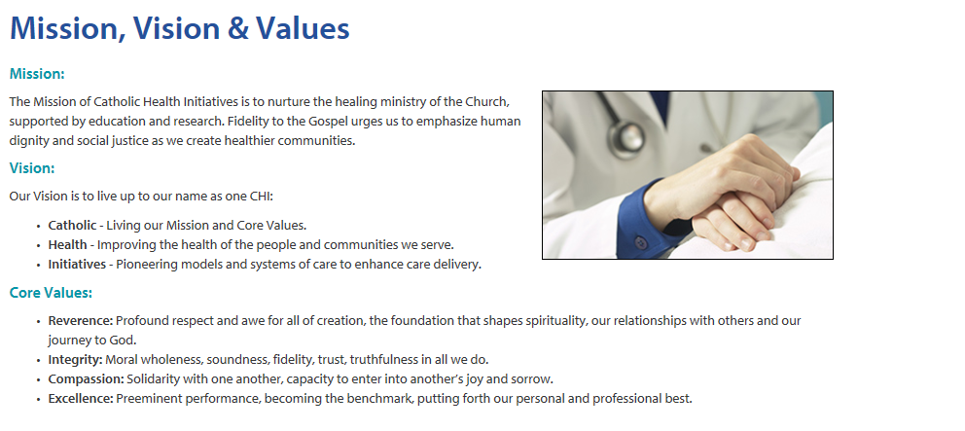

**Appendix B**

**Nursing Satisfaction Questionnaire**

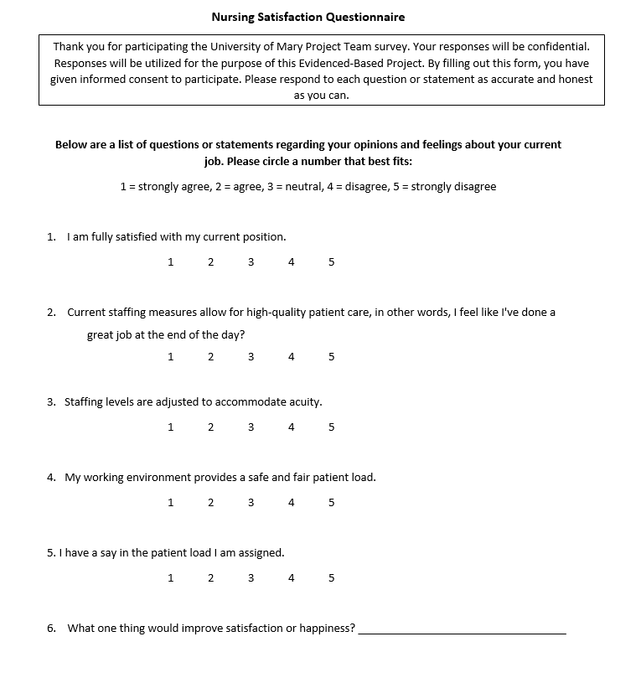

**Appendix C**

**Press Ganey Performance Scorecard**

|  |  |  |  |  |
| --- | --- | --- | --- | --- |
|  |  |  |  |  |
|  |  |  |  |  |
|  |  |  |  |  |
|  |  |  |  |  |
|  |  |  |  |  |
| **Measures** | **2019** | **2020** |  | **Gap** |
| **Overall** | 66.20% | 54.90% |  | -11.30% |
| **Nurses** | 79.00% | 64.80% |  | -14.20% |
| Friendliness/courtesy of the nurses |  |  |  |  |
| Nurses kept you informed | 82.50% | 65.70% |  | -16.80% |
| Nurses' attitude toward requests | 79.00% | 61.10% |  | -17.90% |
| Skill of the nurses | 83.90% | NA |  | NA |
| Attention to special/personal needs | 77.40% | 67.60% |  | -9.80% |
| Promptness response to call | 73.80% | NA |  | NA |
|  |  |  |  |  |
| **Personal Issues** | 65.70% | 55.10% |  | -10.60% |
| Staff concern for your privacy | 75.80% | 59.50% |  | -16.30% |
| Response concerns/complaints | 60.00% | 54.30% |  | -5.70% |
| How well your pain was controlled | 64.30% | 54.50% |  | -9.80% |
| Staff include decisions retirement | 62.70% | 55.60% |  | -7.10% |
| Staff addressed emotional needs | 64.90% | 51.40% |  | -13.50% |
|  |  |  |  |  |
| **Overall Assessment** | 70.10% | 60.90% |  | -9.20% |
| Staff worked together care for you | 77.80% | 67.60% |  | -10.20% |
| Overall rating of care given | 71.00% | 58.30% |  | -12.70% |
|  |  |  |  |  |
| **CAHPS - Hospital Environment** | 75.40% | 63.50% |  | -11.90% |
| CAHPS - Cleanliness of hospital environment | 77.80% | 59.50% |  | -18.30% |
|  |  |  |  |  |
|  |  |  |  |  |
| CAHPS - Quietness of hospital environment | 73.00% | 67.60% |  | -5.40% |
|  |  |  |  |  |
|  |  |  |  |  |
| **CAHPS - Comm w/ Nurses** | 83.70% | 82.00% |  | -1.70% |
| CAHPS - Nurses treat with courtesy/respect | 93.80% | 89.20% |  | -4.60% |
| CAHPS - Nurses explain in way you understand | 77.80% | 75.70% |  | -2.10% |
| CAHPS - Nurses listen carefully to you | 79.70% | 81.10% |  | 1.40% |
|  |  |  |  |  |
| **CAHPS - Care Transitions** | 53.40% | 39.20% |  | -14.30% |
| CAHPS - Hosp staff took pref into account | 45.20% | 27.00% |  | -18.20% |
| CAHPS - Understood purpose of taking meds | 61.00% | 50.00% |  | -11.00% |
| CAHPS - Good understanding managing health | 54.00% | 40.50% |  | -13.50% |
|  |  |  |  |  |
| **CAHPS - Response of Hosp Staff** | 80.10% | 59.80% |  | -20.30% |
| CAHPS - Help toileting soon as you wanted | 79.50% | 56.00% |  | -23.50% |
| CAHPS - Call button help soon as wanted it | 80.70% | 63.60% |  | -17.10% |
|  |  |  |  |  |
| **CAHPS - Global** |  |  |  |  |
| CAHPS - Recommend the hospital | 68.30% | 66.70% |  | -1.60% |
| CAHPS - Rate hospital 0-10 | 68.80% | 77.80% |  | 9% |

**Appendix C (cont).**

**Appendix D (cont)**

**Staff Pulse Survey**

|  |  |  |  |  |
| --- | --- | --- | --- | --- |
| **Department Summary**  (Med/Surg, OB, ER, OR, Lab, Ultrasound, Respiratory Care, Pharmacy, Facilities Operations, Central Stores, and Family Practice Clinic)   |  | | --- | |  | |  |  |  |
|  |  |  |  |
|  |  |  |  |
|  |  |  |  |
|  |  |  |  |
|  |  |  |  |
| **Measures** | **Dec 2020 Cumulative** | **Full 2020 Survey** | **Cumulative Full** |
| **Engagement** | 72.78 | 71.91 | 0.87 |
| I would like to be working at this organization three years from now. | 81.67 | 82.58 | -0.92 |
| I would recommend this organization to family and friends who need care. | 80.00 | 82.02 | -2.02 |
|  |  |  |  |
| **Mission** |  |  |  |
| The actions of this organization live up to our mission. | 76.54 | 77.40 | -0.86 |
| Senior Leadership is dedicated to serving those who are vulnerable while keeping the ministry financially sustainable. | 66.85 | 66.48 | 0.38 |
| I see our organization’s values consistently demonstrated in my department. | 77.09 | 77.40 | -0.31 |
| My work is meaningful. | 94.41 | 93.79 | 0.63 |
|  |  |  |  |
| **Diversity, Inclusion, Equity, & Belonging** |  |  |  |
| When I speak up, my opinion is valued. | 62.22 | 61.80 | 0.42 |
| I feel like I belong at this organization. | 77.78 | 77.53 | 0.25 |
| This organization provides the same quality of care to all patients. | 86.11 | 85.96 | 0.16 |
|  |  |  |  |
| **My Manager** |  |  |  |
| The person I report to creates an environment of trust. | 71.11 | 70.22 | 0.89 |
| The person I report to actively supports my overall growth and personal development. | 74.44 | 73.03 | 1.41 |
|  |  |  |  |
|  |  |  |  |
| **Career Development** |  |  |  |
| This organization provides quality development and learning opportunities that support my career growth. | 69.44 | 69.66 | -0.22 |
|  |  |  |  |
| **Teamwork** |  |  |  |
| My coworkers and I support each other to be a high-performing team. | 83.89 | 84.83 | -0.94 |
| Members of my team treat one another with respect. | 73.89 | 72.47 | 1.42 |
| Collaboration across departments is a strength for my organization. | 58.89 | 60.11 | -1.22 |
|  |  |  |  |
| **Senior Leadership** |  |  |  |
| Lloyd Dean and his executive team provide clear direction about where we are going as an organization. | 48.85 | 46.20 | 2.65 |
| Acting with integrity is of great importance to my senior leadership team. | 78.33 | 79.21 | -0.88 |
| I see human kindness (kindness and compassion) demonstrated in everyday interactions with others. | 84.36 | 86.44 | -2.08 |
| I believe meaningful action will be taken from this survey. | 51.67 | 55.06 | -3.39 |
|  |  |  |  |
| **Culture of Safety** |  |  |  |
| I would feel safe being treated here as a patient. | 72.57 | 72.22 | 0.34 |
| Disagreements in this work setting are resolved appropriately (i.e., not who is right, but what is best for the patient). | 74.34 | 72.22 | 2.11 |
| I have the support I need from others in this work setting to care for patients. | 88.50 | 87.96 | 0.53 |
|  |  |  |  |
| **Well-Being** |  |  |  |
| I can enjoy my personal time without focusing on work matters. | 70.00 | 68.54 | 1.46 |



**Appendix E**



**Proposed Acuity-Based Staffing Tool**  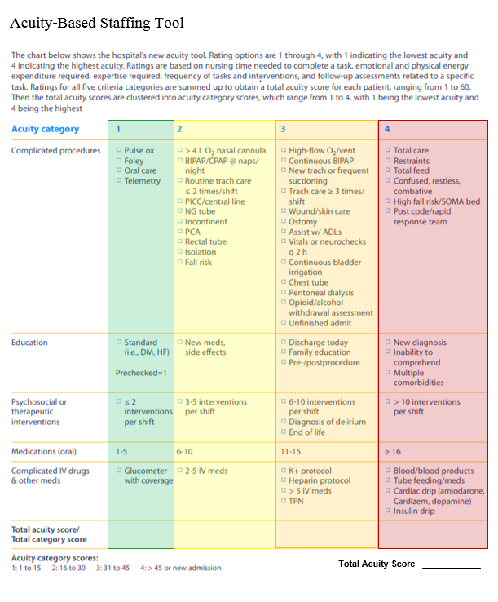

**Appendix F**

**Action Plan**

**PLACE NEW ACTION PLAN**

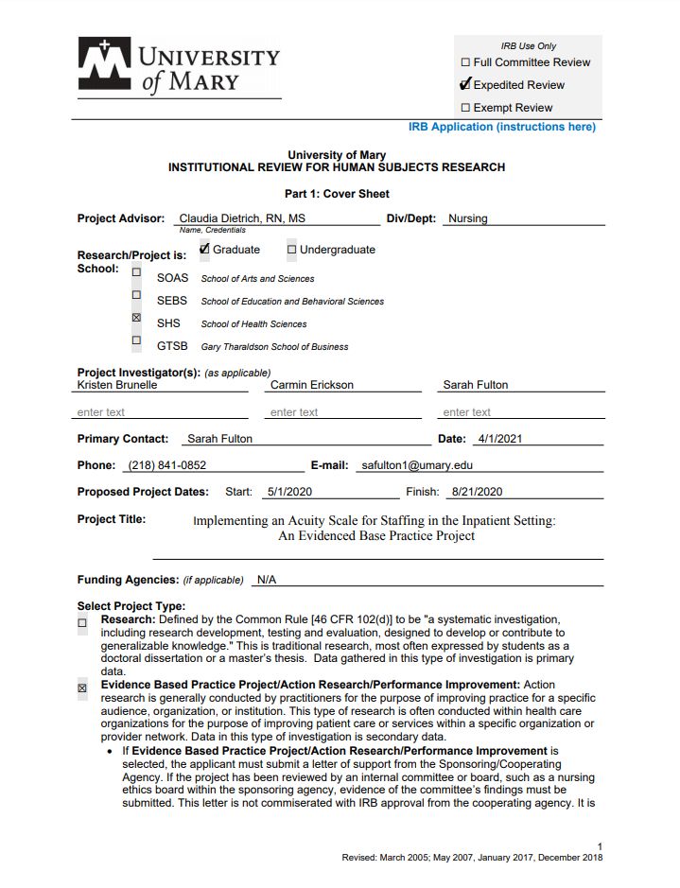**Appendix G**

**Institutional Review Board Application**

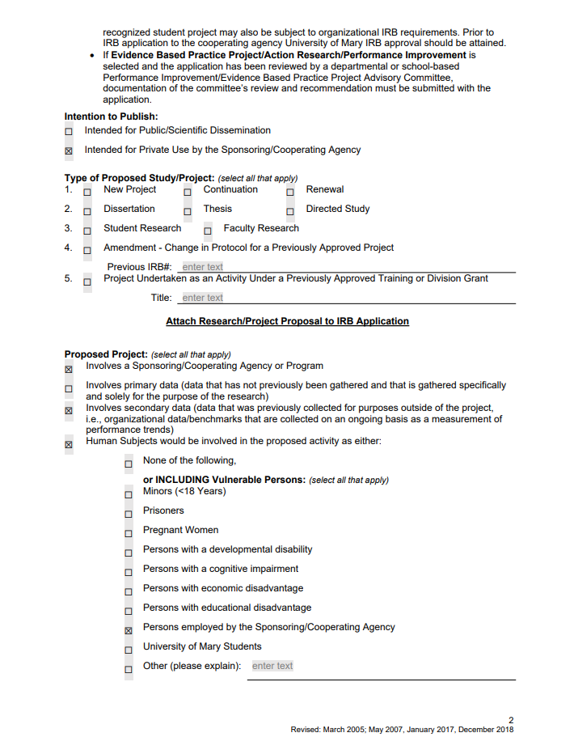

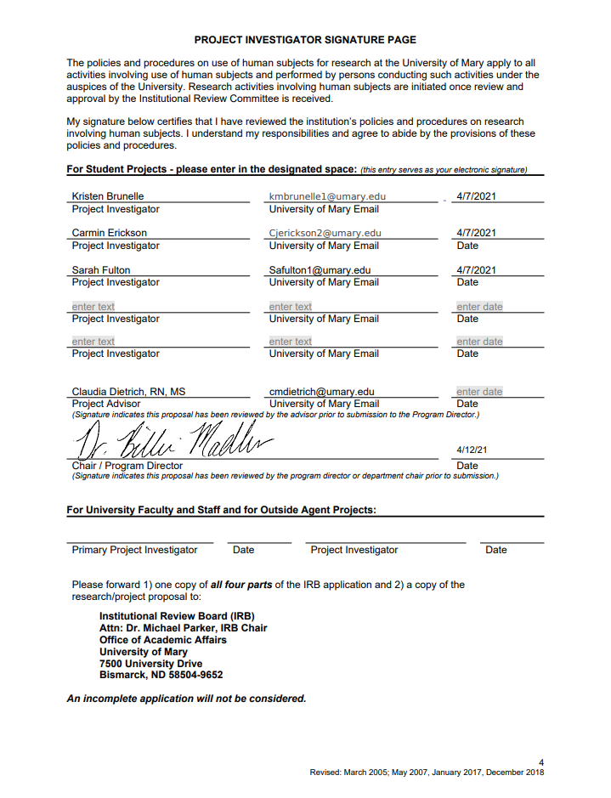

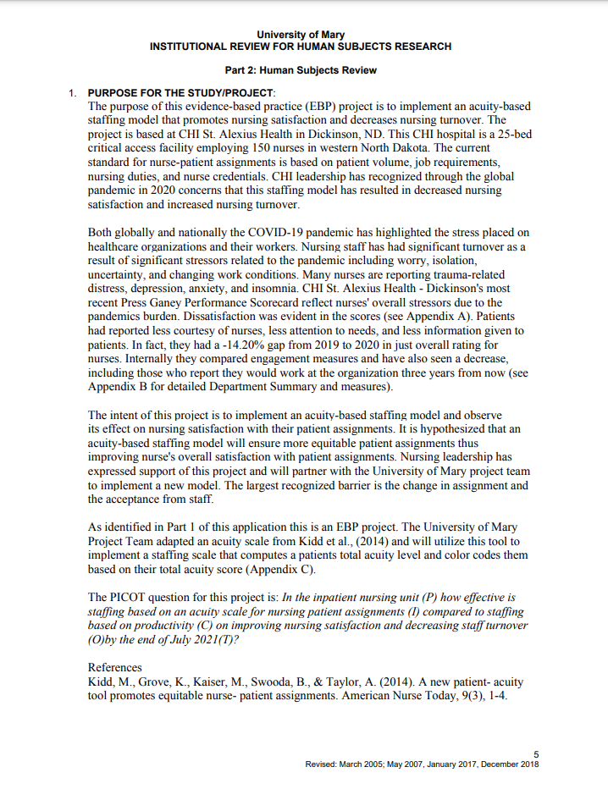

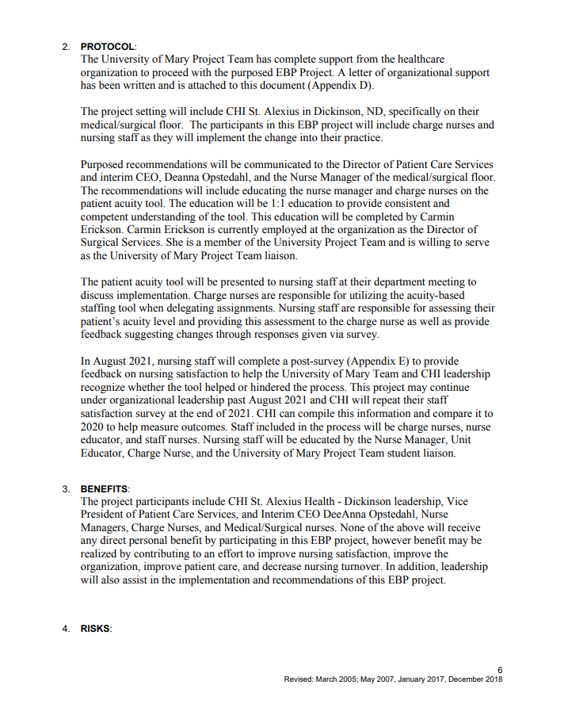

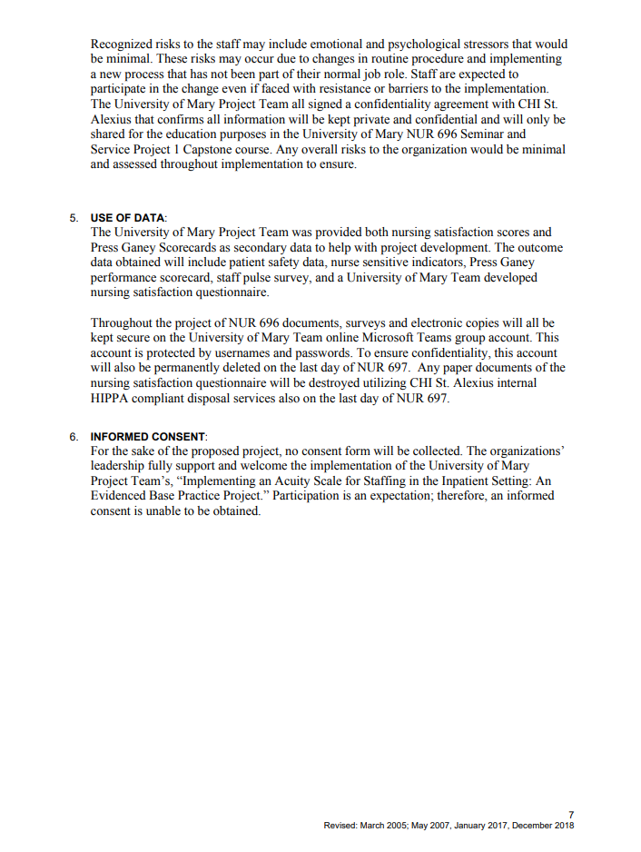

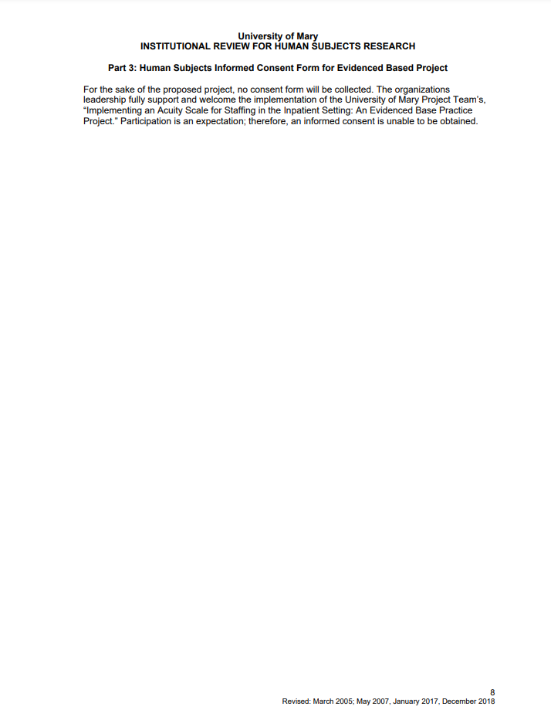

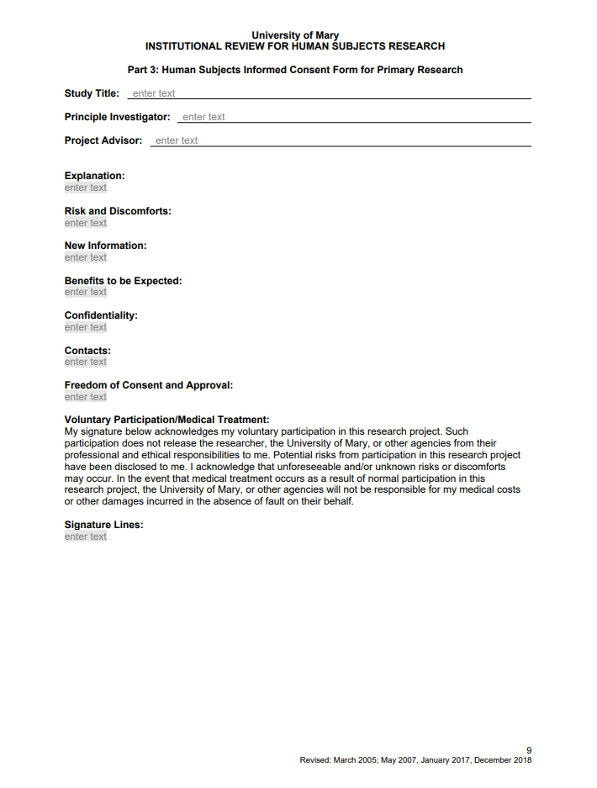

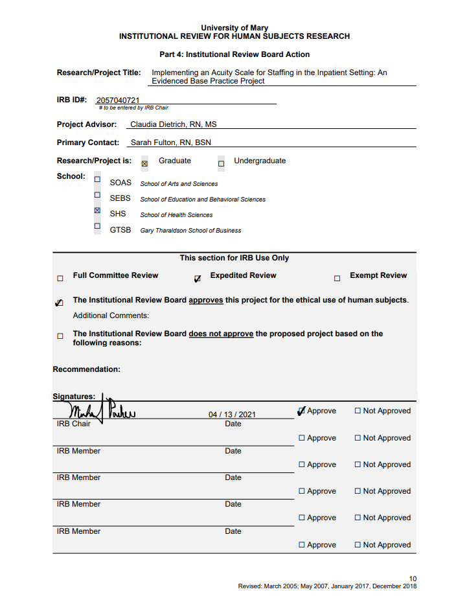

**Appendix H**

**Organizational Letter of Support**

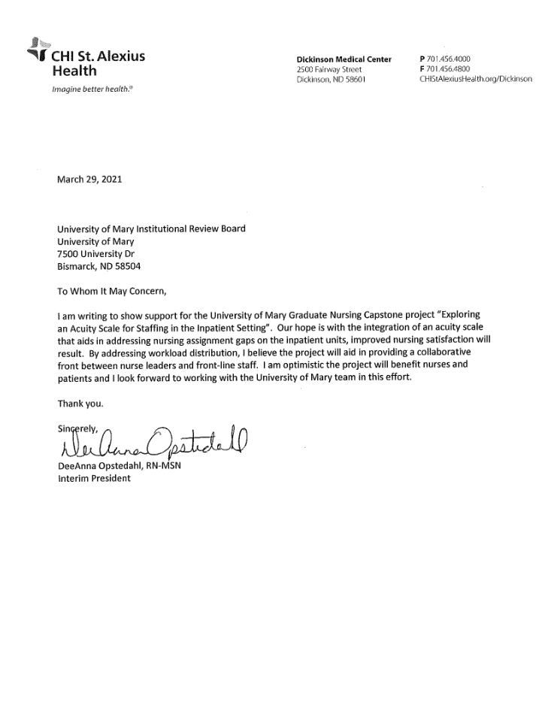

**Appendix I**

**Organizational Letter of Support**

